Report:

1. Principal Component Analysis (PCA)
   1. Implement PCA form scratch
2. Python code from scratch

***Importing supporting libraries*:**



***This is the PCA function which will take data and number of principle components and return the transformed data***

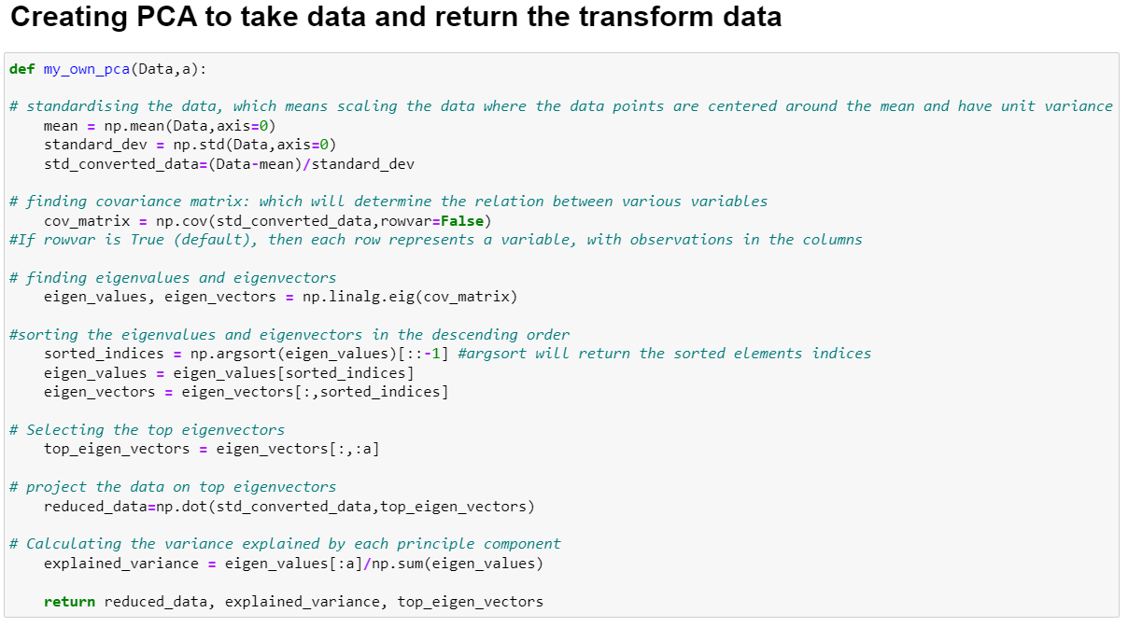

***Reading the test and train data excluding the last column:***

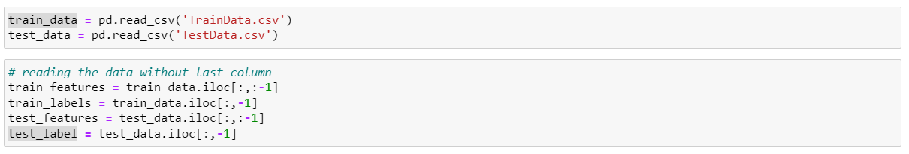

***Apply your PCA implementation to the Train dataset to reduce the dimensionality of the images and choosing significant amount of variance as 95%***

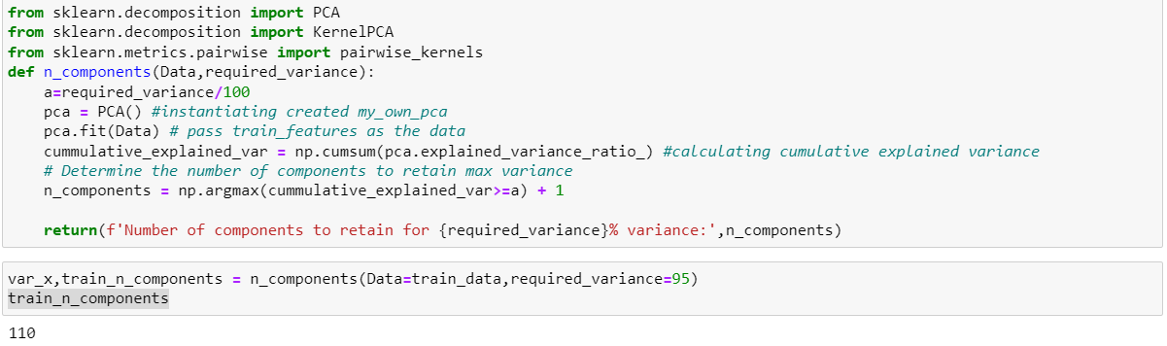

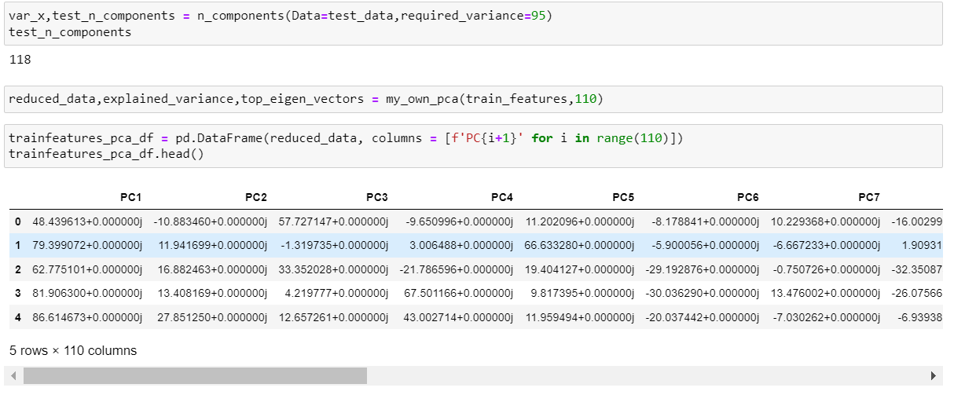

***Applying PCA with the help of Sklearn:***

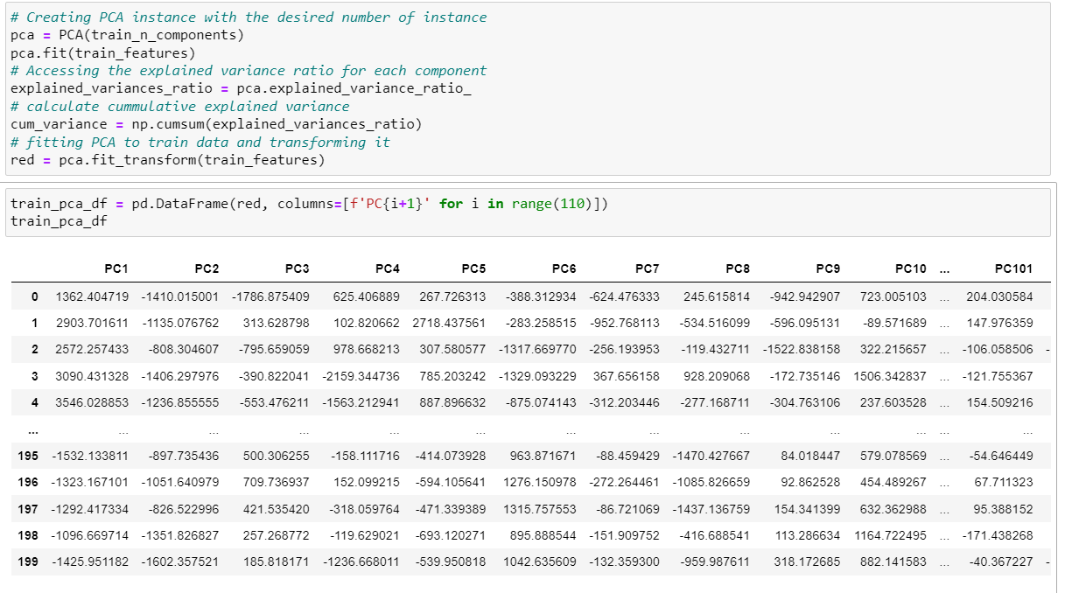

**Part 2:**

***KCPA with RBF Kernel:***

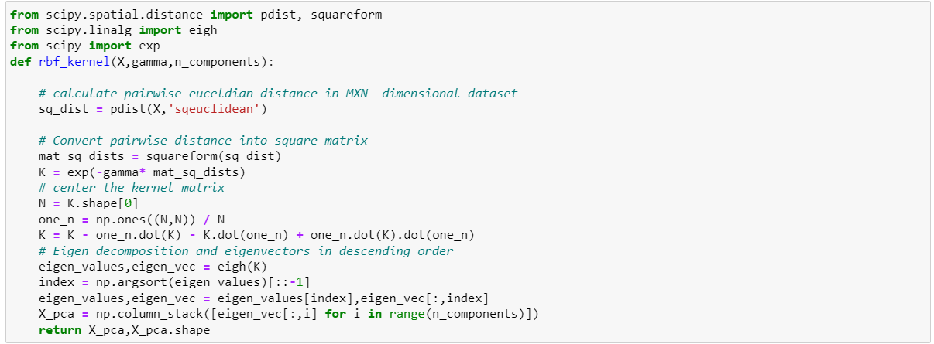

***KCPA with polynomial Kernel:***

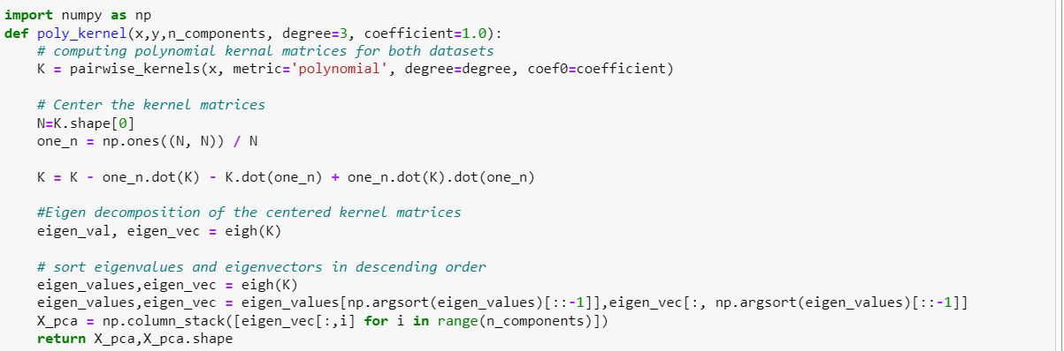

***KCPA with linear kernel:***

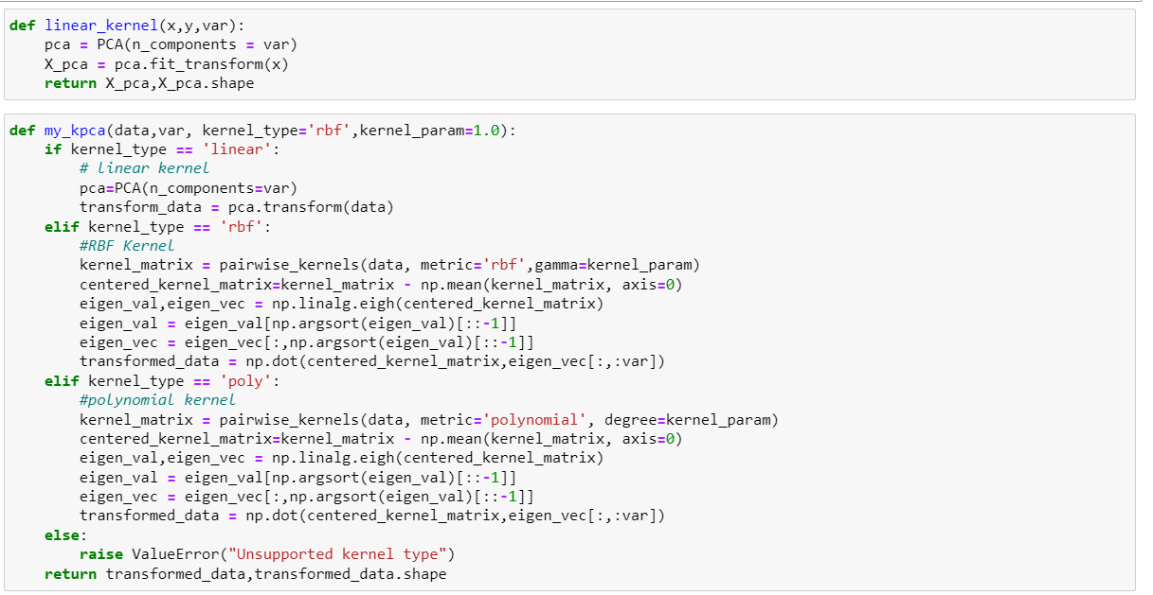

***Applying Radial Base Function on train dataset:***

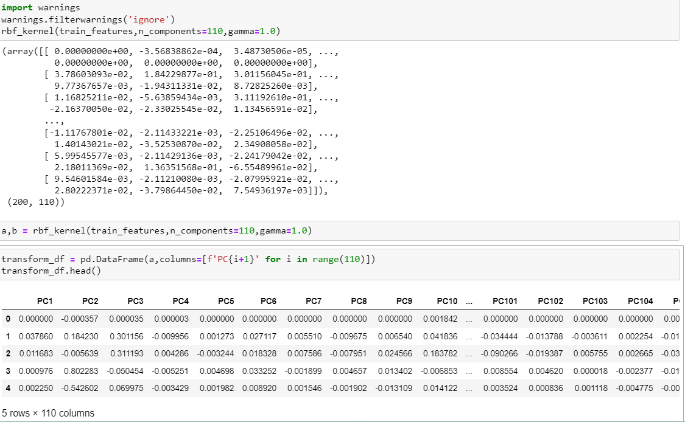

***Applying polynomial kernel on train dataset:***

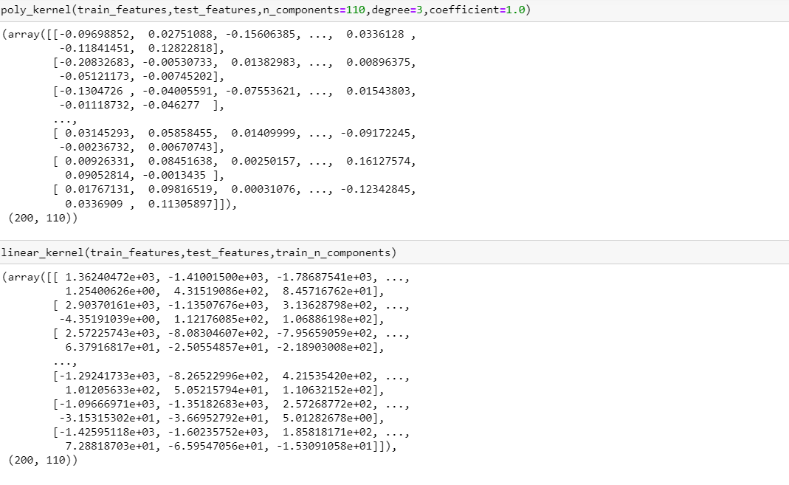

***Finally applying liner kernel:***

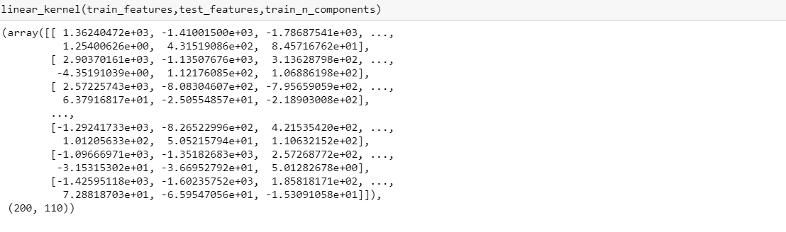

***Applying My_own_kcpa on train_data:***

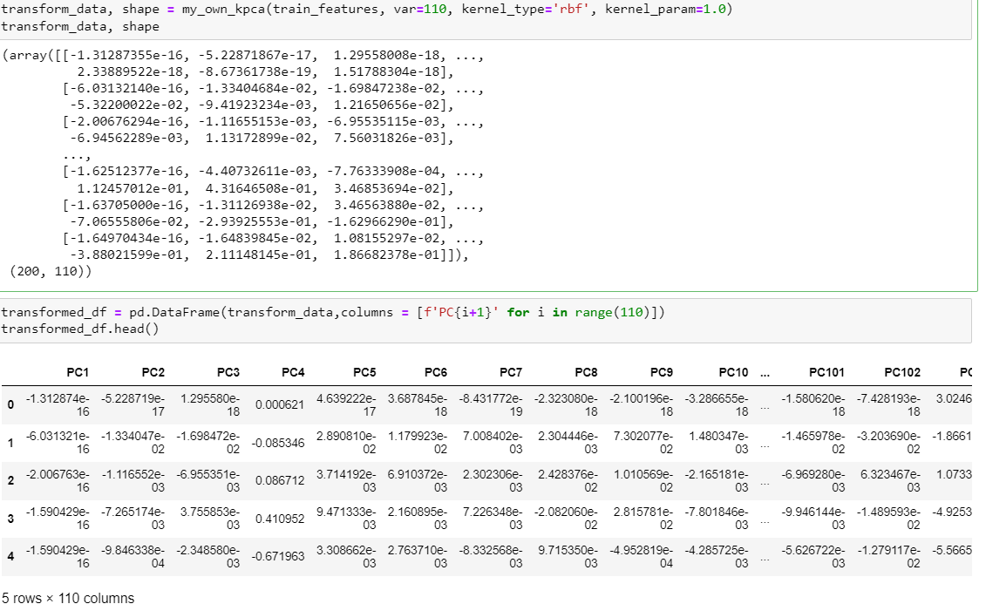

**Part 3: Testing and evaluation.**

***Using sklearn on train and test data_set:***

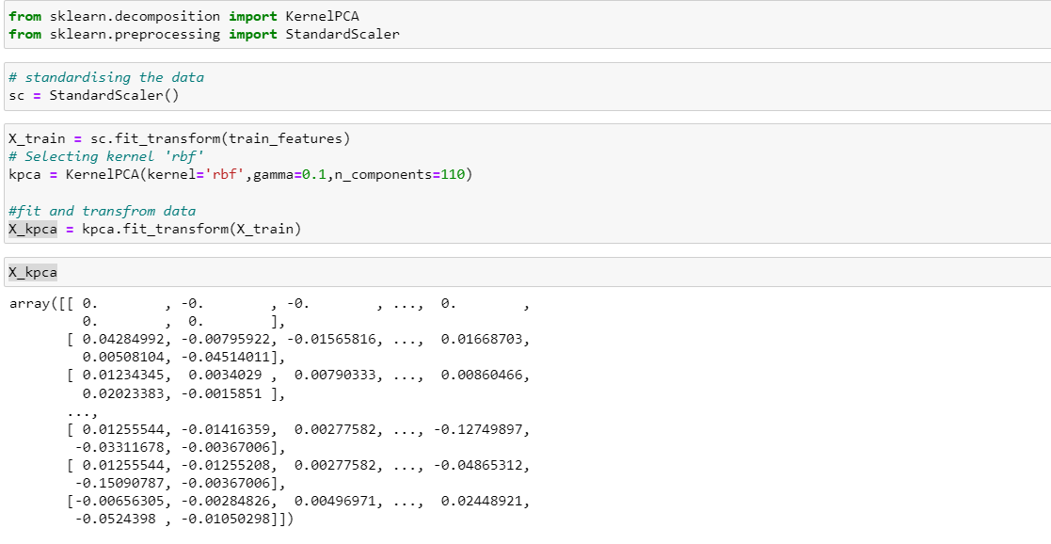

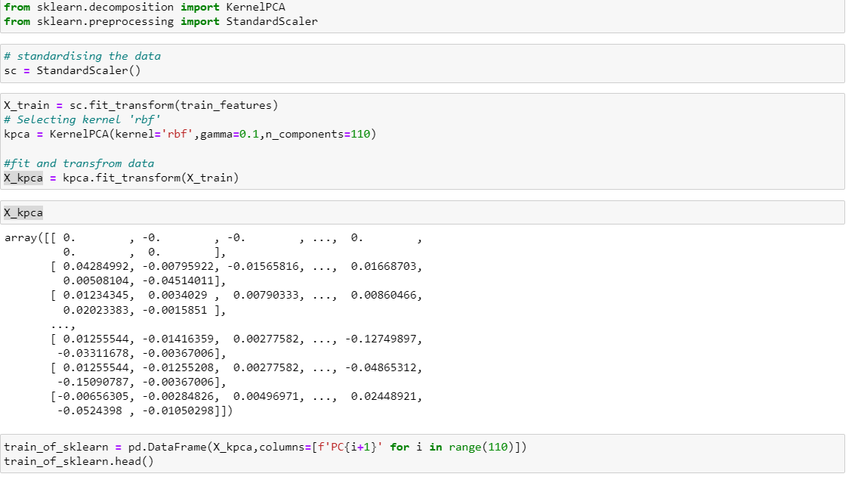

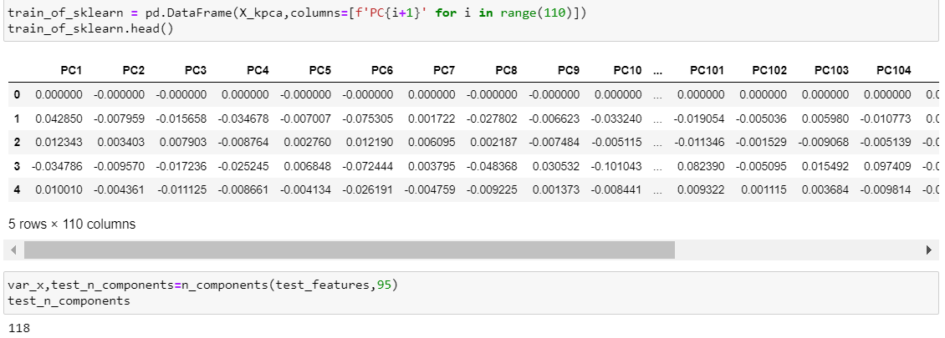

***Applying on test data set:***

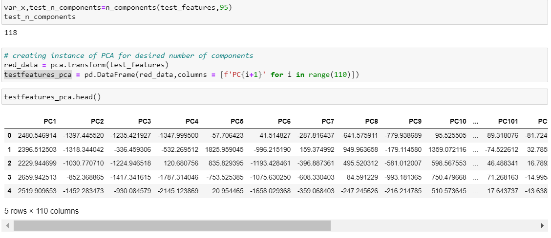

***Applying RBF and polynomial kernel on test_data:***

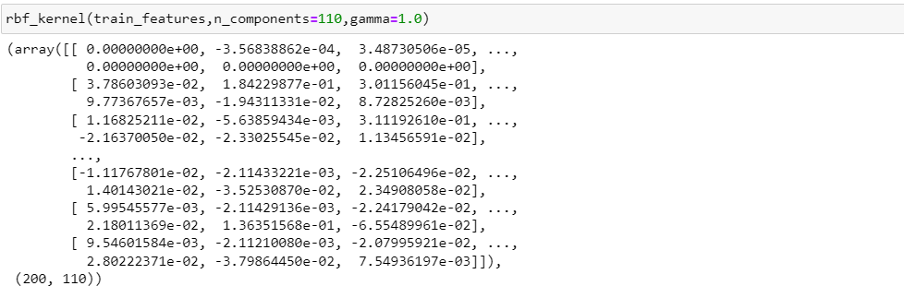

***Polynomial:***

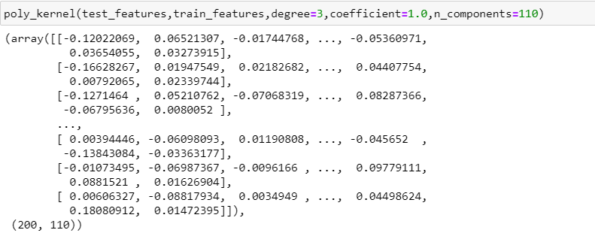

***Calculation of accuracy:***

***Creating classifier:***

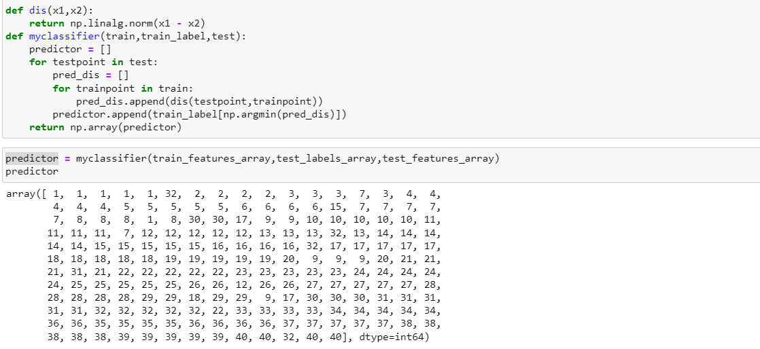

***Function for accuracy:***

